Project Design Phase-II

Data Flow Diagram & User Stories

|  |  |
| --- | --- |
| Date | 05 November 2022 |
| Team ID | PNT2022TMID42630 |
| Project Name | Nutrition Assistant Application |
| Maximum Marks | 4 Marks |

# Data Flow Diagrams:

A Data Flow Diagram (DFD) is a traditional visual representation of the information flows within a system. A neat and clear DFD can depict the right amount of the system requirement graphically. It shows how data enters and leaves the system, what changes the information, and where data is stored.

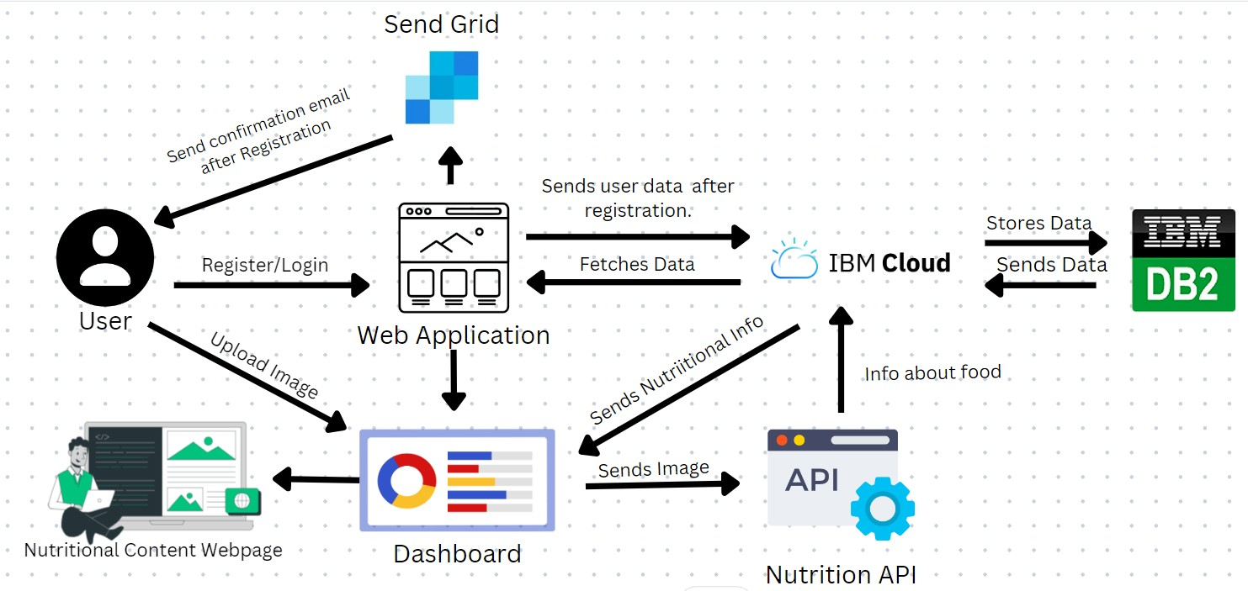

# User Stories

Use the below template to list all the user stories for the product.

|  |  |  |  |  |  |  |
| --- | --- | --- | --- | --- | --- | --- |
| **User Type** | **Functional**  **Requirement (Epic)** | **User Story Number** | **User Story / Task** | **Acceptance criteria** | **Priority** | **Release** |
| Customer (Web user) | Registration | USN-1 | As a user, I can register for the application by entering my email, password, and confirming my password. | I can access my account / dashboard | High | Sprint-1 |
|  |  | USN-2 | As a user, I will receive confirmation email once I have registered for the application | I can receive confirmation email & click confirm | High | Sprint-1 |
|  |  | USN-3 | As a user, I can register for the application through Facebook | I can register & access the dashboard with Facebook  Login | Low | Sprint-2 |
|  |  | USN-4 | As a user, I can register for the application through Gmail | I can register by using Gmail .. | Medium | Sprint-2 |
|  | Login | USN-5 | As a user, I can log into the application by entering email & password | I can login to my account by entering email &  password. | High | Sprint-1 |
|  | Dashboard | USN-6 | As a user, I can navigate through the dashboard. | I can navigate through the dashboard and upload the  photo. | High | Sprint-3 |
|  | Forgot Password | USN-7 | As a user, I can reset my password using my Gmail. | I can reset my account password. | High | Sprint-4 |
|  | Upload Image | USN-8 | As a user, I can upload image in the application. | I can upload image in the application. | High | Sprint-3 |
|  | View Food Information | USN-9 | As a user, after uploading the image the application should redirect to this page. | I can view the nutritional contents of the | High | Sprint-3 |
|  | View History of items | USN-10 | As a user, I can be able to view history of items. | I can view the previous image uploads, that I have searched in the  application. | Low | Sprint-4 |
| Admin(Web User) | Registration | USN-11 | As a user, I can register for the application. | I can access my account / dashboard | Medium | Sprint-4 |
|  | Login | USN-12 | As a user, I can log into the application. | I can login to my account by entering admin credentials | Medium | Sprint-4 |
|  | Dashboard | USN-13 | As a user, I can navigate through the dashboard. | I can navigate through the dashboard and perform admin specific tasks. | Medium | Sprint-4 |